

Default Report
www.cte.tcu.edu

04/28/2009 00:00:00 - 05/27/2009 23:59:59 | Wednesday May 27, 2009 - 10:51:53

Table of Contents
1. General Statistics 2
2. Summary of Activity for Report Period 3
3. Technical Statistics and Analysis 4
4. Top 20 Pages 5
5. Top 20 Documents 7
6. Top Entry Pages 9
7. Top Entry Files 10
8. Single Access Pages 11
9. Most Downloaded Files 12
10. Visitors by Number of Visits 13
11. Activity Level by Day of the Week 14
12. Top Referring Sites 15

General Statistics | Help

The Visits graph displays the overall number of visits to your Web site. The General Statistics table provides an overview of the activity for your Web site during the specified time frame.

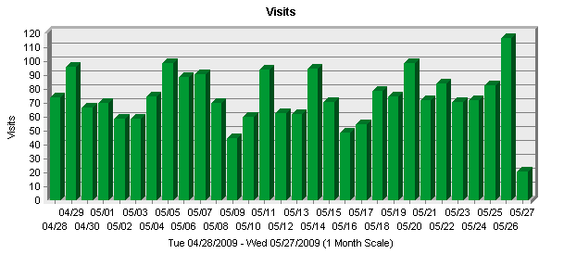

General Statistics
 | Entire Site (Successful) | 12,522
  Hits
 | Average per Day | 417
 | Home Page | 686
Page Views | Page Views | 2,895
Page Views | Average per Day | 96
Page Views | Average per Unique Visitor | 3
Page Views | Document Views | 2,891
Visits | Visits | 2,216
Visits | Average per Day | 73
Visits | Average Visit Length | 00:16:26
Visits | Median Visit Length | 00:16:55
Visits | International Visits | 0%
Visits | Visits of Unknown Origin | 100%
Visits | Visits from United States | 0%
Visits | Visits Referred by Search Engines | 1,164
Visits | Visits from Spiders | 725
Visitors | Unique Visitors | 843
Visitors | Visitors Who Visited Once | 634
Visitors | Visitors Who Visited More Than Once | 209

Summary of Activity for Report Period | Help

This page summarizes general server activity.

Summary of Activity for Report Period
 | 79
  Average Number of Visits per Day on Weekdays
Average Number of Hits per Day on Weekdays | 498
Average Number of Visits per Weekend | 117
Average Number of Hits per Weekend | 386
Most Active Day of the Week | Fri
Least Active Day of the Week | Sat
Most Active Date | May 08, 2009
Number of Hits on Most Active Date | 2,213
Least Active Date | May 03, 2009
Number of Hits on Least Active Date | 96
Most Active Hour of the Day | 12:00-12:59
Least Active Hour of the Day | 20:00-20:59

Technical Statistics and Analysis | Help

This page shows the reliability of your Web site. The table shows the total number of hits for the site, how many were successful, how many failed, and it calculates the percentage of hits that failed.

Technical Statistics and Analysis
 | 13,880
  Total Hits
Successful Hits | 12,522
Failed Hits | 1,358
Failed Hits as Percent | 9.78%
Redirected Hits | 6,255
Redirected Hits as Percent | 45.06%
Cached Hits | 6,255
Cached Hits as Percent | 45.06%

Top 20 Pages | Help

This page identifies the most popular Web pages on your site, shows you how often they were viewed, and displays the average length of time the page was viewed.

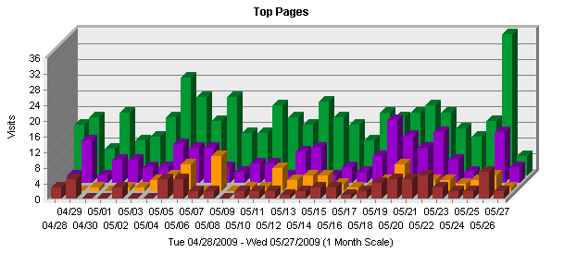

Top Pages
 |  | Views | % of Total Views | Visits | Avg. Time Viewed
  Pages
1 | Center for Teaching Excellence at Texas Christian University  http://www.cte.tcu.edu/ | 686 | 23.69% | 446 | 00:03:12
2 | Center for Teaching Excellence at Texas Christian University  http://www.cte.tcu.edu/ workshopsevents.html | 403 | 13.92% | 194 | 00:01:15
3 | Center for Teaching Excellence at Texas Christian University  http://www.cte.tcu.edu/ staff.htm | 84 | 2.9% | 79 | 00:01:30
4 | Center for Teaching Excellence at Texas Christian University  http://www.cte.tcu.edu/ facultyservices.htm | 84 | 2.9% | 79 | 00:03:11
5 | Center for Teaching Excellence at Texas Christian University  http://www.cte.tcu.edu/ new_adjunct_faculty.htm | 83 | 2.86% | 75 | 00:01:34
6 | Center for Teaching Excellence at Texas Christian University  http://www.cte.tcu.edu/ teachingstrategies.htm | 76 | 2.62% | 72 | 00:02:31
7 | Center for Teaching Excellence at Texas Christian University  http://www.cte.tcu.edu/ portfolio_workshop.htm | 79 | 2.72% | 70 | 00:00:59
8 | Center for Teaching Excellence at Texas Christian University  http://www.cte.tcu.edu/ new_FT_faculty.htm | 71 | 2.45% | 68 | 00:04:11
9 | Center for Teaching Excellence at Texas Christian University  http://www.cte.tcu.edu/ TAGAPhD.htm | 60 | 2.07% | 55 | 00:02:20
10 | Center for Teaching Excellence at Texas Christian University  http://www.cte.tcu.edu/ thankateacher.htm | 73 | 2.52% | 50 | 00:02:23
11 | Center for Teaching Excellence at Texas Christian University  http://www.cte.tcu.edu/ Koehler_Center_Newsletter_Archive. htm | 266 | 9.18% | 42 | 00:00:20
12 | Center for Teaching Excellence at Texas Christian University  http://www.cte.tcu.edu/ onetoone.asp | 52 | 1.79% | 41 | 00:06:15
13 | Center for Teaching Excellence at Texas Christian University  http://www.cte.tcu.edu/ 151.htm | 36 | 1.24% | 33 | 00:04:23
14 | Center for Teaching Excellence at Texas Christian University  http://www.cte.tcu.edu/ tagg.html | 33 | 1.13% | 30 | 00:00:35
15 | Center for Teaching Excellence at Texas Christian University  http://www.cte.tcu.edu/ 146.htm | 33 | 1.13% | 30 | 00:38:47
16 | Center for Teaching Excellence at Texas Christian University  http://www.cte.tcu.edu/ ClassroomVideotaping.htm | 32 | 1.1% | 29 | 00:01:46
17 | Center for Teaching Excellence at Texas Christian University  http://www.cte.tcu.edu/ 402.htm | 35 | 1.2% | 29 | 00:02:53
18 | Center for Teaching Excellence at Texas Christian University  http://www.cte.tcu.edu/84.htm | 30 | 1.03% | 27 | 00:01:56
19 | Center for Teaching Excellence at Texas Christian University  http://www.cte.tcu.edu/ 144.htm | 29 | 1% | 26 | 00:03:05
20 | Center for Teaching Excellence at Texas Christian University  http://www.cte.tcu.edu/ onlineresources.htm | 30 | 1.03% | 26 | 00:00:34
Subtotal For the Page Views Above |  | 2,275 | 78.58% | N/A | N/A
Total For the Log File |  | 2,895 | 100% | N/A | N/A

Top 20 Documents | Help

This page identifies the most popular documents on your site, shows you how often they were viewed, and displays the average length of time the page was viewed.

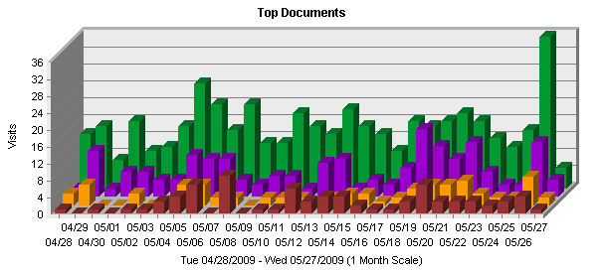

Top Documents
 |  | Views | % of Total Views | Visits | Avg. Time Viewed
  Documents
1 | Center for Teaching Excellence at Texas Christian University  http://www.cte.tcu.edu/ | 686 | 23.72% | 446 | 00:03:12
2 | Center for Teaching Excellence at Texas Christian University  http://www.cte.tcu.edu/ workshopsevents.html | 403 | 13.93% | 194 | 00:01:15
3 | Center for Teaching Excellence at Texas Christian University  http://www.cte.tcu.edu/ facultyservices.htm | 84 | 2.9% | 79 | 00:03:11
4 | Center for Teaching Excellence at Texas Christian University  http://www.cte.tcu.edu/ staff.htm | 84 | 2.9% | 79 | 00:01:30
5 | Center for Teaching Excellence at Texas Christian University  http://www.cte.tcu.edu/ new_adjunct_faculty.htm | 83 | 2.87% | 75 | 00:01:34
6 | Center for Teaching Excellence at Texas Christian University  http://www.cte.tcu.edu/ teachingstrategies.htm | 76 | 2.62% | 72 | 00:02:31
7 | Center for Teaching Excellence at Texas Christian University  http://www.cte.tcu.edu/ portfolio_workshop.htm | 79 | 2.73% | 70 | 00:00:59
8 | Center for Teaching Excellence at Texas Christian University  http://www.cte.tcu.edu/ new_FT_faculty.htm | 71 | 2.45% | 68 | 00:04:11
9 | Center for Teaching Excellence at Texas Christian University  http://www.cte.tcu.edu/ TAGAPhD.htm | 60 | 2.07% | 55 | 00:02:20
10 | Center for Teaching Excellence at Texas Christian University  http://www.cte.tcu.edu/ thankateacher.htm | 73 | 2.52% | 50 | 00:02:23
11 | Center for Teaching Excellence at Texas Christian University  http://www.cte.tcu.edu/ Koehler_Center_Newsletter_Archive. htm | 266 | 9.2% | 42 | 00:00:20
12 | Center for Teaching Excellence at Texas Christian University  http://www.cte.tcu.edu/ onetoone.asp | 52 | 1.79% | 41 | 00:06:15
13 | Center for Teaching Excellence at Texas Christian University  http://www.cte.tcu.edu/ 151.htm | 36 | 1.24% | 33 | 00:04:23
14 | Center for Teaching Excellence at Texas Christian University  http://www.cte.tcu.edu/ tagg.html | 33 | 1.14% | 30 | 00:00:35
15 | Center for Teaching Excellence at Texas Christian University  http://www.cte.tcu.edu/ 146.htm | 33 | 1.14% | 30 | 00:38:47
16 | Center for Teaching Excellence at Texas Christian University  http://www.cte.tcu.edu/ ClassroomVideotaping.htm | 32 | 1.1% | 29 | 00:01:46
17 | Center for Teaching Excellence at Texas Christian University  http://www.cte.tcu.edu/ 402.htm | 35 | 1.21% | 29 | 00:02:53
18 | Center for Teaching Excellence at Texas Christian University  http://www.cte.tcu.edu/84.htm | 30 | 1.03% | 27 | 00:01:56
19 | Center for Teaching Excellence at Texas Christian University  http://www.cte.tcu.edu/ 144.htm | 29 | 1% | 26 | 00:03:05
20 | Center for Teaching Excellence at Texas Christian University  http://www.cte.tcu.edu/ CTW01120116.htm | 29 | 1% | 26 | 00:09:10

Top Entry Pages | Help

This page identifies the first page viewed when a visitor visits your site. The most common entry page is usually the home page, but other common entry pages include specific URLs that go directly to a particular page.

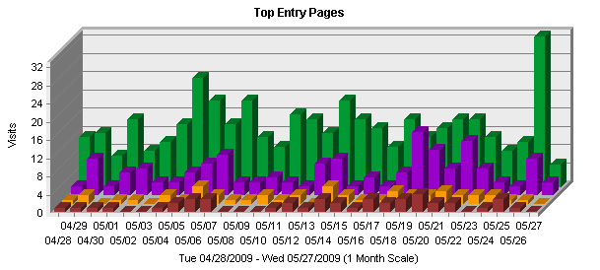

Top Entry Pages
 | Page | % of Total | Visits
1 | Center for Teaching Excellence at Texas Christian University  http://www.cte.tcu.edu/ | 33.44% | 408
2 | Center for Teaching Excellence at Texas Christian University  http://www.cte.tcu.edu/ workshopsevents.html | 12.86% | 157
3 | Center for Teaching Excellence at Texas Christian University  http://www.cte.tcu.edu/ new_adjunct_faculty.htm | 3.85% | 47
4 | Center for Teaching Excellence at Texas Christian University  http://www.cte.tcu.edu/ portfolio_workshop.htm | 3.6% | 44

Top Entry Files | Help

This page identifies the first hit from a visitor visiting your site. This is most likely the home page but, in some cases it may also be specific URLs that go directly to a particular file or page.

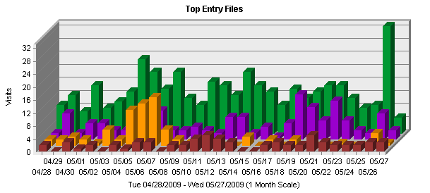

Top Entry Files
 | File | % of Total | Visits
1 | Center for Teaching Excellence at Texas Christian University  http://www.cte.tcu.edu/ | 18.14% | 402
2 | Center for Teaching Excellence at Texas Christian University  http://www.cte.tcu.edu/ workshopsevents.html | 6.9% | 153
3 | http://www.cte.tcu.edu/ Grading_Procedures_for_TCU.pdf | 3.61% | 80
4 | http://www.cte.tcu.edu/ UsingPowerPoint0Effectively.ppt | 2.97% | 66

Single Access Pages | Help

This page identifies the pages on your Web site that visitors open, then exit from, without viewing any other page.

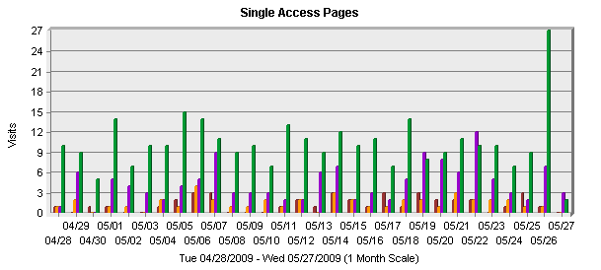

Single Access Pages
 | Pages | % of Total | Visits
1 | Center for Teaching Excellence at Texas Christian University  http://www.cte.tcu.edu/ | 32.32% | 311
2 | Center for Teaching Excellence at Texas Christian University  http://www.cte.tcu.edu/ workshopsevents.html | 13.72% | 132
3 | Center for Teaching Excellence at Texas Christian University  http://www.cte.tcu.edu/ new_adjunct_faculty.htm | 4.57% | 44
4 | Center for Teaching Excellence at Texas Christian University  http://www.cte.tcu.edu/ portfolio_workshop.htm | 4.15% | 40

Most Downloaded Files | Help

This page identifies the most popular files downloaded from your site.

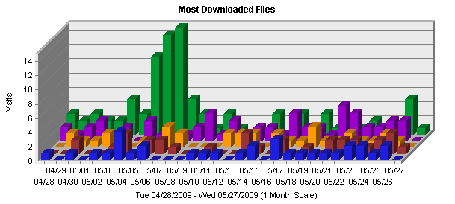

Most Downloaded Files
 | File | No. of Downloads | % of Total Downloads | Visits
1 | http://www.cte.tcu.edu/ Grading_Procedures_for_TCU.pdf | 104 | 4.2% | 95
2 | http://www.cte.tcu.edu/ Discount_Tickets_2007.pdf | 63 | 2.54% | 60
3 | http://www.cte.tcu.edu/ Financial_Services_2008.pdf | 41 | 1.65% | 36
4 | http://www.cte.tcu.edu/ TCU_Campus_Recreation_.pdf | 34 | 1.37% | 32
5 | http://www.cte.tcu.edu/ Transitions.pdf | 34 | 1.37% | 32

Visitors by Number of Visits | Help

This page shows the distribution of visitors based on how many times each visitor visited your site.

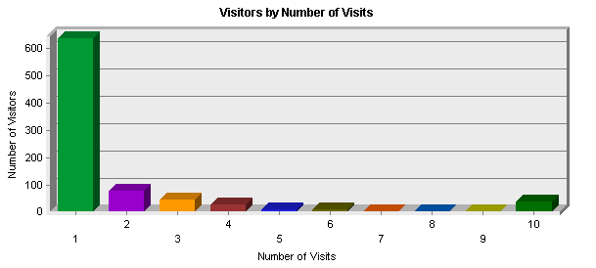

Visitors by Number of Visits
 | Number of Visitors | % of Total Unique Visitors
  Number of Visits
1 visit | 634 | 75.2%
2 visits | 76 | 9.01%
3 visits | 44 | 5.21%
4 visits | 28 | 3.32%
5 visits | 9 | 1.06%
6 visits | 8 | 0.94%
7 visits | 3 | 0.35%
8 visits | 1 | 0.11%
9 visits | 3 | 0.35%
10 or more visits | 37 | 4.38%

Activity Level by Day of the Week | Help

This page shows the activity for each day of the week within the reporting period. Unsuccessful hits are not included.

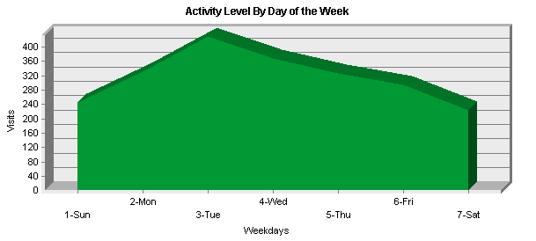

Activity Level by Day of the Week
 | Day | Hits | % of Total Hits | Visits
1 | Sun | 799 | 6.38% | 246
2 | Mon | 1,048 | 8.36% | 331
3 | Tue | 2,774 | 22.15% | 428
4 | Wed | 1,497 | 11.95% | 367
5 | Thu | 2,499 | 19.95% | 325
6 | Fri | 3,159 | 25.22% | 295
7 | Sat | 746 | 5.95% | 224
Total Weekdays |  | 10,977 | 87.66% | 1,746
Total Weekend |  | 1,545 | 12.33% | 470

Top Referring Sites | Help

This page identifies the domain names and numeric IP addresses that refer visitors to your site. This information will be displayed only if your server is logging this information.

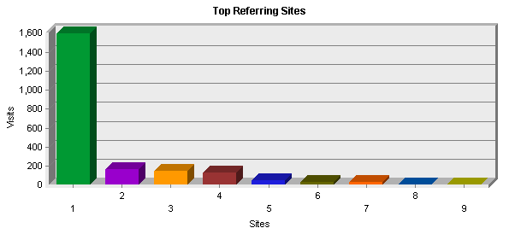

Top Referring Sites
 | Site | Visits
1 | No Referrer | 1,593
2 | http://search.tcu.edu | 170
3 | http://www.google.com | 152
4 | http://www.cte.tcu.edu | 131
5 | http://www.elearning.tcu.edu | 45
6 | http://www.tcu.edu | 28
7 | http://search.yahoo.com | 27
8 | http://search.live.com | 5
9 | http://search.msn.com | 5

